TASK REPORT
Color Hierarchy in a Flipkart-Style Shopping Cart UI

1. Introduction
This task explores color hierarchy and typography in a shopping cart interface inspired by Flipkart’s blue e-commerce branding. The design compares Primary, Secondary, and Disabled button states to communicate importance and availability. The supplied screenshot is included as the output reference.

2. Objectives
• Create a clear shopping cart action area.
• Use color contrast to emphasize the main action.
• Use different font weights to reinforce importance.
• Show a secondary action without competing with the primary action.
• Represent an unavailable action with muted styling.

3. Design Overview
The screen uses a blue header, light gray background, and white content card. A breadcrumb (“Shopping › Cart”) establishes context. The card contains “Choose an Action,” supporting text, and three evenly spaced buttons. A secure-checkout note sits below the card.

4. Color and Typography Hierarchy
Primary — Place Order: blue fill (#2874F0), white text, bold/Semi Bold; the most prominent checkout action.
Secondary — Continue Shopping: white fill, blue border and text (#2874F0), medium weight; a less prominent alternative.
Disabled — Apply Coupon: gray fill (#E0E0E0), gray text (#757575), regular weight; communicates unavailability.

5. Layout and Interface Elements
• Header: blue banner with cart icon and “My Shopping Cart.”
• Breadcrumb: “Shopping › Cart.”
• Content card: rounded white panel with subtle border and generous spacing.
• Action row: three equal-width examples with labels and captions.
• Footer note: shield icon and “Safe and secure checkout.”

6. Implementation Procedure in Figma
1. Create a desktop frame (recommended 1440 × 900 px) with a light gray background.
2. Build the blue header and add the cart icon and title.
3. Create a white card with heading, subtitle, divider, and three columns.
4. Draw the buttons and apply the correct fills, borders, and corner radius.
5. Add labels using Inter: Semi Bold for Primary, Medium for Secondary, Regular for Disabled.
6. Align buttons and captions consistently; review spacing and contrast.
7. Export or capture the completed frame as a PNG.

7. Observations and Results
The primary action attracts attention through saturated blue and stronger typography. The outlined secondary action remains visible without dominating. Gray styling makes the disabled action appear subdued. Consistent dimensions and alignment make the states easy to compare.

8. Conclusion
The design demonstrates how color, contrast, and font weight establish a clear action hierarchy in an e-commerce interface. Users can identify the main checkout action, distinguish the alternative, and understand that the coupon action is unavailable.

9. Screenshot of Output
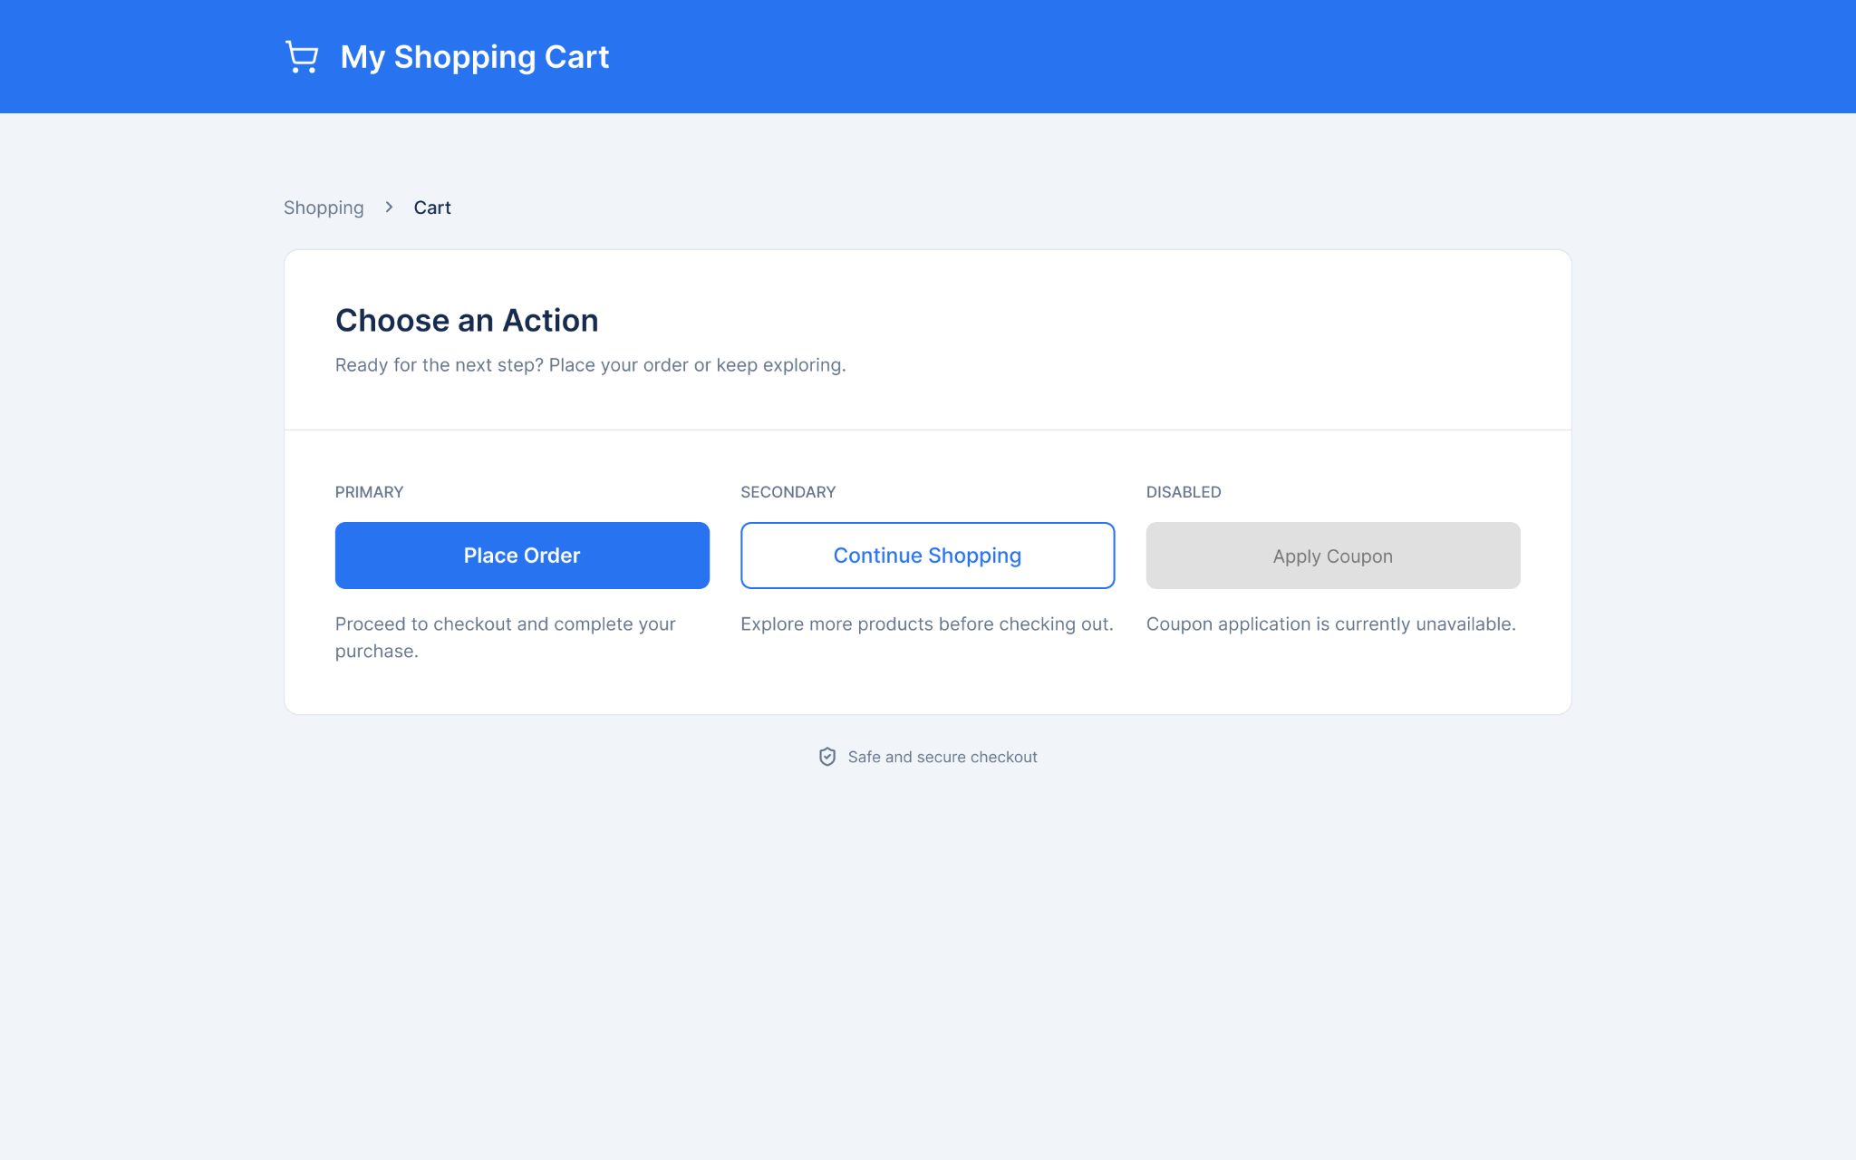
Figure 1. User-provided screenshot showing the shopping cart page and the three button states.

